NEWTON’S LAWS REVIEW – CH. 3 & 4

- Identical twins are riding in identical wagons. A friend gives the first wagon a push of 5 N and gives the second wagon a push of 6 N. Which twin will experience the greater acceleration? Explain.

- When the bad guy is hit by a bullet in the movies, he is often hurled backwards several feet shattering a plate-glass window in the process. Use conservation of momentum to decide if this is likely to occur in reality (find the velocity of bad guy after the collision). Assume the bad guy is motionless before the collision and has a mass of 70 kg, the bullet has a velocity of 400 m/s before the collision and has a mass of 0.01 kg, and the collision is inelastic.

- Two figure skaters push against each other and move in opposite directions across the ice. Describe the action-reaction pair in this situation. Draw a picture and label the action-reaction forces. Which of the two forces is greater? Which skater, the man or the woman, will probably accelerate faster? Explain

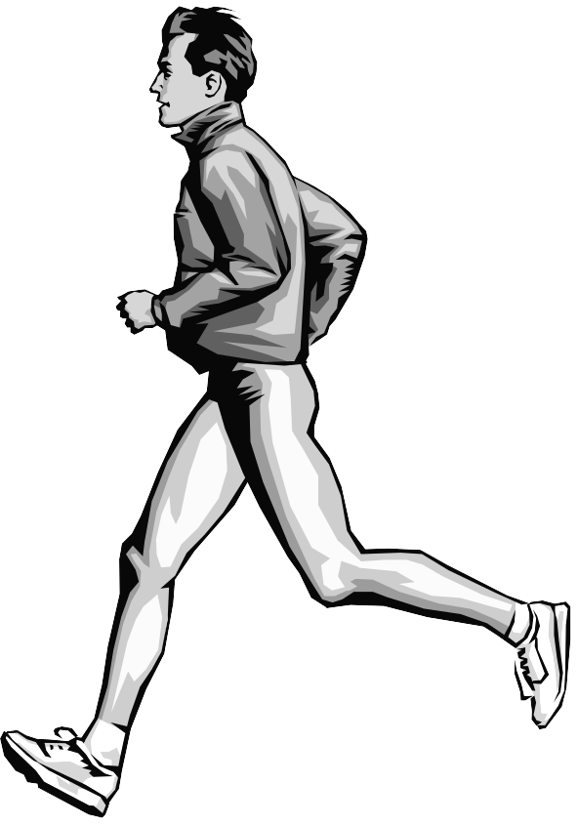
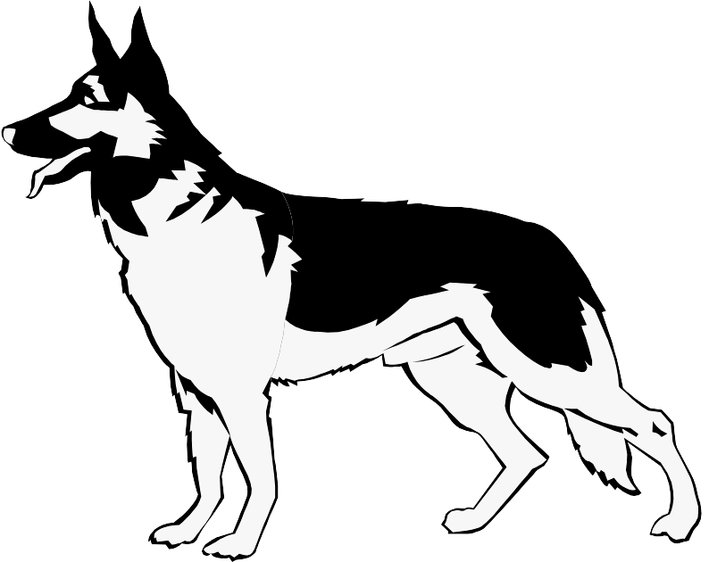
- A man is walking his dog on a leash. Both the man and dog are moving forward, and the leash is pulled tight. List as many action-reaction pairs as you can for this situation.
NEWTON’S LAWS REVIEW – CH. 3 & 4
answer key

- The twin pushed with 6N of force will accelerate faster. According to Newton’s Second Law, force and acceleration are directly proportional. Therefore, more force produces more acceleration for objects of equal mass.

- Before the collision:
momentum of bullet = 4 kg⋅m/s
momentum of man = 0 kg⋅m/s
total momentum = 4 kg⋅m/s
After the collision:
momentum of man+bullet = 4 kg⋅m/s
velocity of man+bullet = 0.06 m/s
Since this speed is quite slow, it’s unlikely the bad guy would be hurled backward with enough force to shatter a window.

- The man exerts a force on the woman in one direction. The woman exerts an equal force on the man in the opposite direction. These two forces are equal according to Newton’s Third Law. The woman will probably accelerate faster since she has less mass. According to Newton’s Second Law, mass and acceleration are directly proportional. Therefore, less mass produces more acceleration when given equal force.

- Dog pulls leash left. Leash pulls dog right.
Leash pulls man left. Man pulls leash left.
Dog pushes down on ground. Ground pushes up on dog.
Man pushes down on ground. Ground pushes up on man.

