Name Period Date

Force & Acceleration – Ch. 4

Part A – Force Calculations
- How much force is needed to accelerate a 1000-kg car at a rate of 3 m/s²?
given | work
answer:
- If a 70-kg swimmer pushes off a pool wall with a force of 250 N, what is her acceleration?
given | work
answer:
- Find the mass of a football player who weighs 1250 N.
given | work
answer:

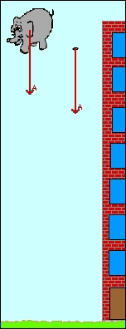
Part B – Read the following statements regarding the examples of the falling elephant and feather from class. Indicate whether each statement is True (T) or False (F).

Falling Objects without Air Resistance
- ____ The elephant has a greater weight and therefore falls faster.
- ____ The elephant and the feather each have the same weight and therefore fall at the same rate.
- ____ The elephant has both greater weight and greater inertia than the feather and therefore falls at the same rate as the feather.
Falling Objects with Air Resistance
- ____ The elephant experiences less air resistance than the feather and therefore falls faster.
- ____ The elephant weighs more than the feather. Since it takes more air resistance to counteract its weight, the elephant fall faster.
- ____ The elephant has a greater acceleration due to gravity than the feather and therefore falls faster.

