Name Period Date

Forces in Fluids – Ch. 8.5
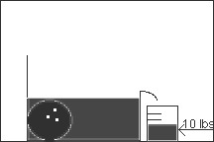
- Is the following statement regarding the diagram to the right true or false? If it’s false, explain what’s wrong with the statement and/or how to fix it.
The bowling ball sinks because there is not enough water in the container to support the weight of the ball.

- What principle explains the scenario in #1? _________________________________________

- The small piston of a hydraulic lift has an area of 25 m² and the large piston has an area of 100 m². If 30 N of force is applied to the small piston, how much force will be exerted by the large piston?

- What principle explains the scenario in #3? _________________________________________
According to this principle what quantity remains constant throughout a fluid?

- Explain why the shape of an airplane wing (airfoil) produces lift.

- What principle explains the scenario in #5? _________________________________________

- Explain how an atomizer works. How does it get the liquid in the bottle up to the spray nozzle?

- What principle explains the scenario in #7? _________________________________________

