Name Period Date

Energy & Work – Ch. 5
Part A – Work
- A game show contestant won a prize by pushing a bowling ball 20 m using her nose. The amount of work done was 1470 J. How much force did the contestant exert on the ball?
given | work | answer
- Carlos does a chin-up in gym class and raises himself 0.8 m. If Carlos has a mass of 62 kg, how much work does he accomplish? (Remember, mass is not a force!)
given | work | answer
- A football player picks up the football, runs with it, and throws it to a teammate. During which of these actions is work being done on the football? Explain.

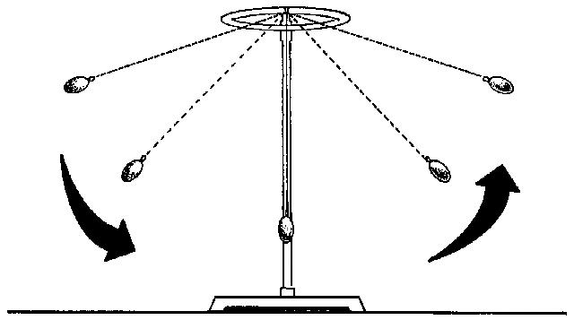
Part B – Conservation of Energy
- On the diagram of the pendulum, identify the position of maximum potential energy with the letter “P”. Identify the position of maximum kinetic energy with the letter “K”. Identify the position where kinetic energy is increasing with the letter “I”. Identify the position where the kinetic energy is decreasing with the letter “D”.
- Imagine dropping a soccer ball. The first bounce will be highest, and each bounce after that will be lower until the ball stops bouncing. Describe the energy changes that take place and explain how energy is conserved.

