SIMPLE CIRCUITS LAB
Can you imagine a world without electricity? It is hard to believe that electrical energy became commercially available less than 100 years ago.
The appliances plugged into the wall outlets of a room are part of an electrical circuit. The simplest type of electric circuit contains three elements: a source of electrical energy (such as a dry cell), an electrical conductor (such as copper wire), and a device that converts electrical energy into other forms of energy (such as a light bulb).

MATERIALS

- 2 aluminum foil strips
- 2 lead wires
- 1.5 V D-cell
- 2 light bulbs
- tape
- metric ruler
- scissors

PROCEDURE
- Place a piece of paper on the lab table. Cut 2 strips of aluminum foil that are each 1 cm × 10 cm.
- Tape the end of one lead wire to the positive terminal of the D-cell. Tape the end of the second lead wire to the negative terminal of the D-cell. Use tape to attach the aluminum foil strips to the paper as shown in Figure 1.
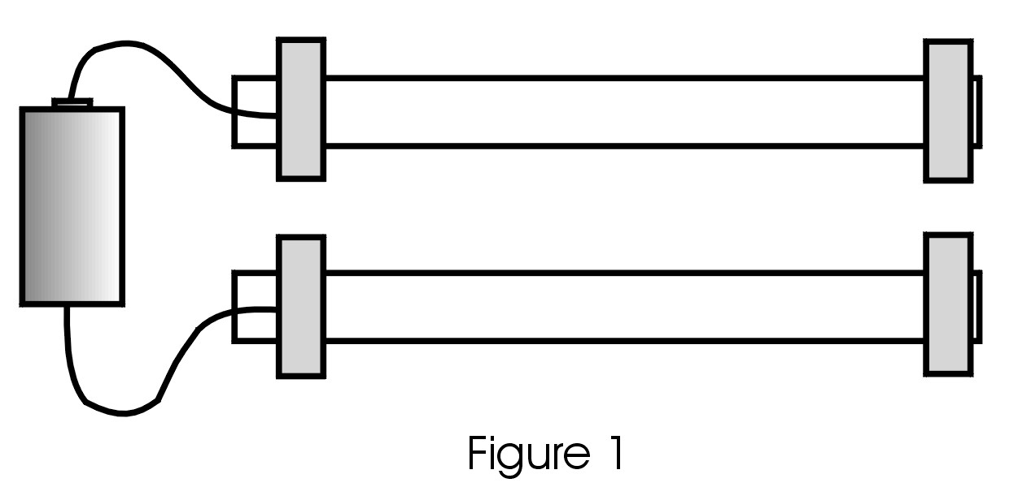
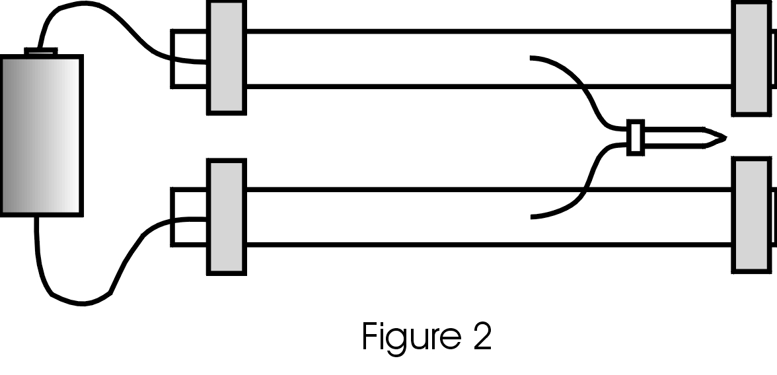
- Poke the free end of one lead wire through the top aluminum strip and tape it in place. Poke the free end of the second lead wire through the bottom aluminum strip and tape it in place as shown in Figure 1.
Series Circuit
- Press the exposed end of one lead wire from the light bulb onto the top aluminum strip. Press the other lead wire from the light bulb onto the bottom aluminum strip as shown in Figure 2.
- Record your observations of the light in your lab notebook. Note its brightness.
- Cut a 1-cm gap toward the right end of the bottom strip and tape down the ends. Record your observations of the light.
- Insert the second light across the gap in the bottom strip. Press one lead wire onto end segment of the strip as shown in Figure 3.
- Record your observations of both lights. Note if the brightness of Light 1 has changed. Compare the current brightness of both lights.
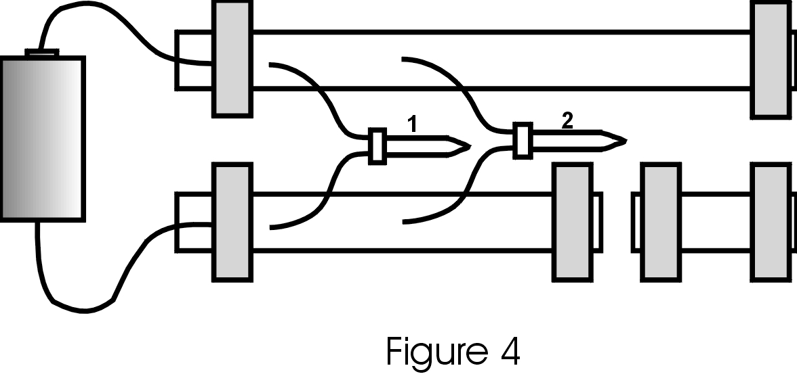
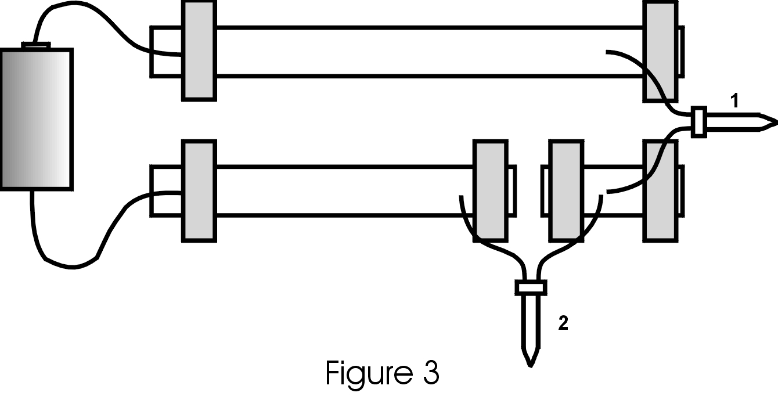
- Record your prediction of what will happen to Light 2 if Light 1 is removed. Remove Light 1 and record your observations.
Parallel Circuit
- Move Light 1 so that it connects the top strip to the left segment of the bottom strip. Attach Light 2 in the same manner as shown in Figure 4.
- Record your observations of both lights. Note their brightness.
- Record your prediction of what will happen if Light 1 is removed. Remove Light 1 and record your observations.
- Replace Light 1 and record your observations of both lights. Note any change in brightness.
- Record your prediction of what will happen if Light 2 is removed. Remove Light 2 and record your observations.

OBSERVATIONS
Record observations as directed in the procedure.

CONCLUSIONS
- The brightness of a light in a circuit is directly related to the current in the part of the circuit containing the light. Use this information to contrast series and parallel circuits in terms of the following properties:
- What happens to the current when a light is removed from the circuit?
- What happens to the current when a light is added to the circuit?
- How much of 1.5-V potential difference is supplied to each light?
- Houses are wired using parallel circuits. Explain at least TWO disadvantages of wiring a house using series circuits.

