Science Topics

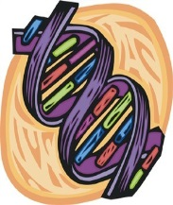
Welcome to Science! It will be a fun and exciting year. This year in science, we will explore various forms of life science. The topics we will be focusing on include:
- Anatomy
- Genetics
- Ecology

How am I graded in Science?
Tests – 40%
Quizzes – 30%
Classwork – 15%
Homework – 15%
**The Grading Policy is based on weighing the grades out of 100%. All the grades will be categorized by the following and weighed with the percentage next to the category.**
You are expected to come to class prepared! You must bring your ISN, a pen/pencil, agenda, folder, and any assignments that are due. Textbooks will be stored in the classroom.
I have read and understand the course outline.
___________________________________________ ____________________
Student Signature Date

